# Host a static website using nginx

Install Nginx:

1. Sudo apt-get install nginx
2. Sudo systemctl start nginx or sudo systemctl status nginx, or sudo systemctl stop nginx
3. Sudo systemctl reload nginx

### Setup firewall:

1. Sudo apt install ufw
2. Sudo ufw allow “Nginx Full”
3. Sudo ufw enable
4. Suod ufw reload

Set up a dummy site

1. Cd /var/www
2. Sudo mkdir winn-static-server
3. Sudo chown marvin:marvin -R winn-static-server
4. Sudo chmod 0755 winn-static-server
5. Cd winn-static-server
6. Mkdir media
7. Created index.html

Configure Nginx

1. Cd /etc/nginx
2. Cd sites-available
3. Sudo vim winn-static.conf

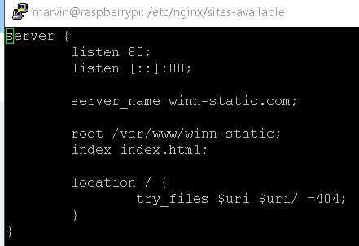

1. Enable the site

sudo ln -s /etc/nginx/sites-available/winn-static.conf /etc/nginx/sites-enabled/

1. Sudo nginx -t to test if the conf files are ok.
2. Sudo systemctl restart nginx
3. You can use “rm” to remove the symlink file. E.g., Sudo rm default

Test your website – it works.

# **Logs**

Writing web logs takes resources. If you want to save these resources, disable logging.

##  
# Logging Settings  
##access_log /var/log/nginx/access.log;  
error_log /var/log/nginx/error.log;

# **Client Side Caching**

Telling our clients to cache resources like js, css, and images files can significantly improve performance.

server {  
 listen 80;  
 server_name test.jasonrigden.com;  
 root /home/jason/www;  
 index index.html;  
   
 # Media: images, icons, video, audio, HTC  
 location ~* \.(?:jpg|jpeg|gif|png|ico|cur|gz|svg|mp4|ogg|ogv|webm|htc)$ {  
 access_log off;  
 add_header Cache-Control "max-age=2592000";  
 } # CSS and Javascript  
 location ~* \.(?:css|js)$ {  
 add_header Cache-Control "max-age=31536000";  
 access_log off;  
 }  
}

# **Pre-compression**

Compression should be already be activated by default on your server. We can save server resources and get higher compression levels with by pre-compressing our files. We will enable pre-compressed files by editing the main Nginx configuration file.

And just add gzip_static on;

##  
# Gzip Settings  
##  
gzip_static on;  
gzip on;

gzip -v -k -f --best index.html

-v is for verbose, -k is for keeping the original file, -f is to overwrite any older zipped file with the same name, and — best is for the best compression

# **HTTPS**

### Install Certbot

For nginx: sudo apt-get install python-certbot-nginx

IF apache2, sudo apt-get install python-certbot-apache

1. sudo certbot –nginx

### Access your static files:

http://192.168.0.25/media/products/2020/11/11/grey-brim.png